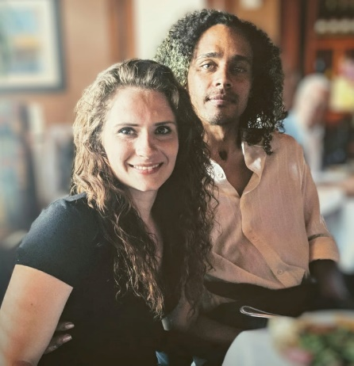
We are excited to continue working to protect people with disabilities during disasters. We shared the 2021: Year In Review to let you know the important work we did in 2021.
Image of Co-Executive Directors, Shaylin Sluzalis and Germán Parodi
As we begin the new year, dangerous and strange weather continues across the United States and around the world. This dangerous weather is a result of climate change. Climate change is the changes in the weather and temperature over a long time.

Disabled people with other marginalized identities are hurt and die more during disasters than people without disabilities. Marginalized identities are labels for groups of people that society decided are too different from themselves. When they do this, they marginalize that group.

COVID-19 is an illness and disaster that has killed over 860,000 people in the United States. Many of the people killed by COVID-19 were Black, Brown, and Indigenous people with disabilities.
The Partnership is the only organization led by disabled people that works to help people with disabilities during disasters.

You can support The Partnership by:
- Reviewing our Service Catalogue here!
- Giving money
- Helping the Disability & Disaster Hotline
- Becoming a Partner

Climate change is going to get worse. Disabled people will continue to get hurt and die more than non-disabled people. You can help disabled people in disasters by supporting The Partnership.

Thank you for your support!

With appreciation,

Shaylin Sluzalis and Germán Parodi

